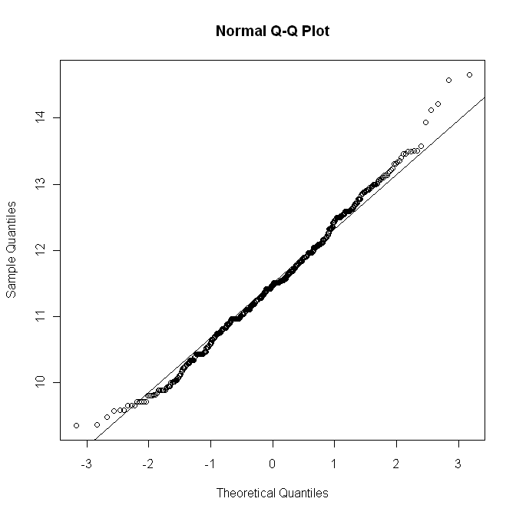
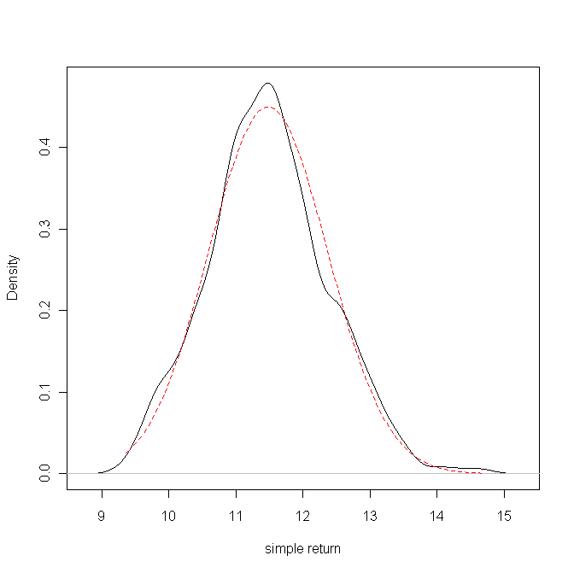
Title:
Shapiro - Wilk Normality Test

Test Results:
STATISTIC:
W: 0.9933
P VALUE:
0.004614

Description:
Sun Jan 18 18:08:48 2009

> jarqueberaTest(nile.test)

Title:
Jarque - Bera Normalality Test

Test Results:
STATISTIC:
X-squared: 6.8061
P VALUE:
Asymptotic p Value: 0.03327

Description:
Sun Jan 18 18:08:48 2009

> ad.Test = adTest(nile.test)
> dagoTest(nile.test)

Title:
D'Agostino Normality Test

Test Results:
STATISTIC:
Chi2 | Omnibus: 6.9094
Z3 | Skewness: 2.5507
Z4 | Kurtosis: 0.6349
P VALUE:
Omnibus Test: 0.0316
Skewness Test: 0.01075
Kurtosis Test: 0.5255

Description:
Sun Jan 18 18:08:48 2009

> lillieTest(nile.test)

Title:
Lilliefors (KS) Normality Test

Test Results:
STATISTIC:
D: 0.0439
P VALUE:
0.004084

Description:
Sun Jan 18 18:08:48 2009

whittle.fit2 = whittleFit(nile.test, order = c(0, 0), subseries = 1, method = c("fgn"),trace = TRUE, spec = FALSE, title = NULL, description = NULL)
Iteration Path:
theta = 0.09854012 0.837425
H = 0.837425 =
95%-CI for H: [ 0.7864071 , 0.888443 ]
95%-CI:
etalow etaup
[1,] 0.7864071 0.888443

> whittle.fit = whittleFit(nile.test, order = c(0, 0), subseries = 1, method = c("farma"),trace = TRUE, spec = FALSE, title = NULL, description = NULL)
Iteration Path:
M = 1
theta = 0.0989124 0.8991992
H = 0.8991992
95%-CI for H: [ 0.839536 , 0.9588624 ]
95%-CI:
etalow etaup
[1,] 0.839536 0.9588624
Warning message:
In optim(par = etatry, fn = .Qmin2) :
one-diml optimization by Nelder-Mead is unreliable: use optimize
>
one-diml optimization by Nelder-Mead is unreliable: use optimize
> d.sperio=fdSperio(nile.test)$d
> d.sperio
[1] 0.4427007
> nile.diffseries = diffseries(nile.test,d.sperio)
> d.new = fdSperio(nile.diffseries)
> d.est.new = d.new$d
> d.est.new
[1] -0.006904546
> d.hurst=diffseries(nile.test,0.337425)
> nile.hurst=diffseries(nile.test,0.337425)
> whittle.fit2 = whittleFit(nile.hurst, order = c(0, 0), subseries = 1, method = c("fgn"),trace = TRUE, spec = FALSE, title = NULL, description = NULL)
Iteration Path:
theta = 0.1580748 0.5559218
H = 0.5559218
95%-CI for H: [ 0.5076023 , 0.6042414 ]
95%-CI:
etalow etaup
[1,] 0.5076023 0.6042414
> nile.hurst=diffseries(nile.test,0.39)
> whittle.fit = whittleFit(nile.hurst, order = c(0, 0), subseries = 1, method = c("farma"),trace = TRUE, spec = FALSE, title = NULL, description = NULL)
Iteration Path:
M = 1
theta = 0.1588984 0.5080469
H = 0.5080469
95%-CI for H: [ 0.4483837 , 0.56771 ]
95%-CI:
etalow etaup
[1,] 0.4483837 0.56771
Warning message:
In optim(par = etatry, fn = .Qmin2) :
one-diml optimization by Nelder-Mead is unreliable: use optimize
>
nile.hurst=diffseries(nile.test,0.3991992)
> nile.test = nile
> nile.hurst=diffseries(nile.test,0.3991992)
> whittle.fit = whittleFit(nile.hurst, order = c(0, 0), subseries = 1, method = c("farma"),trace = TRUE, spec = FALSE, title = NULL, description = NULL)
Iteration Path:
M = 1
theta = 0.1589146 0.49875
H = 0.49875
95%-CI for H: [ 0.4390869 , 0.5584131 ]
95%-CI:
etalow etaup
[1,] 0.4390869 0.5584131
Warning message:
In optim(par = etatry, fn = .Qmin2) :
one-diml optimization by Nelder-Mead is unreliable: use optimize
>
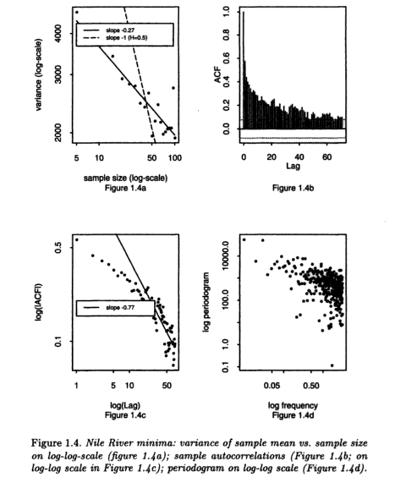
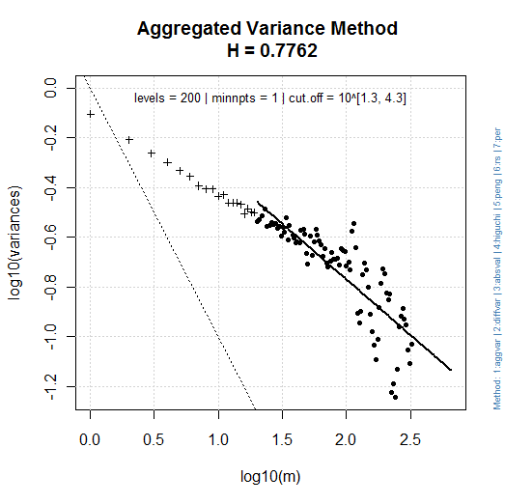 | 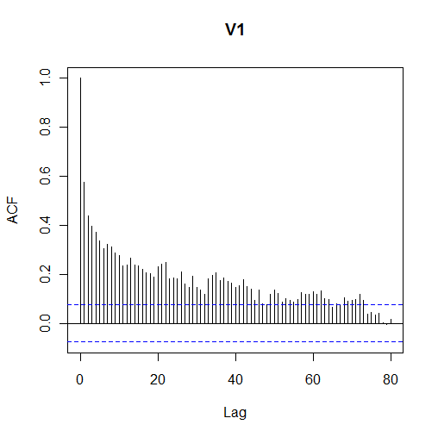
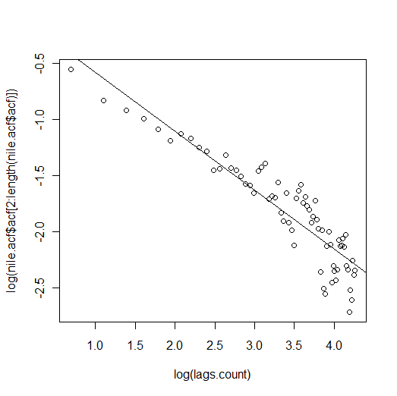 | 